Supplement to
Dorf & Svoboda,
Introduction to Electric Circuits
applies to
5th edition, page 290 Figures 7.11-1,
6th edition, page 276 Figure 7.11-1,
7th edition page 784 Figure 7.10-1.

% Alternative MATLAB style.
% --Takes advantage of Matlab's vector and matrix capabilities.
% --Avoids (slow) if-then and for-end statements.
% --Allows explicit control of plot resolution for smoother curves.
% --Gets the whole job done with just one input file.
% --This file can be easily modified for other situations.
%
%

% Define the plot resolution.
step = 0.1;

% Define the plot segments on the independent (time) axis.
tstart1 = 0; % Segment one starts a t = 0 and goes up to start of next
tstart2 = 2; %
tstart3 = 6; % e.g. Segment 3 is 6 <= t < 14;
tstart4 = 14;
tend = 20;

% Set up the time-axis vector
tend1 = tstart2 - step;
tend2 = tstart3 - step;
tend3 = tstart4 - step;
tend4 = tend;

t1 = [tstart1 : step : tend1];
t2 = [tstart2 : step : tend2];
t3 = [tstart3 : step : tend3];
t4 = [tstart4 : step : tend4];

t = [t1 t2 t3 t4]; % <--concatenates all into one vector

%
%
% Set up the equations for the dependent (current and voltage) axis.
% One equation is needed for each segment.

i1 = 4*ones(size(t1)); % Simply i1 = 4; would not be correctly dimensioned.
i2 = t2 + 2; % The inclusion of a "t2" term brings correct dim.
i3 = 20 - 2*t3;
i4 = -8*ones(size(t4));

v1 = 2*t1 - 5;
v2 = t2.*t2/4 + t2 - 4; % Note: The ".*" operation forces term-by-term
v3 = -t3.*t3/2 + 10*t3 - 31; % array multiplication. A "*" alone.
v4 = -4*t4 + 67; % would call for vector multiplication.

i = [i1 i2 i3 i4]; % <--concatenate all segments into one vector
v = [v1 v2 v3 v4];

%
%
% Set up the plot

plot(t, i, 'k-', t, v, 'b--'); % Line style control: k = black, b = blue
% - = solid, -- = dashed
text(15, 10, 'v(t), V');
text(10, -5, 'i(t), A');
title('Capacitor voltage and current');
xlabel('Time, s');

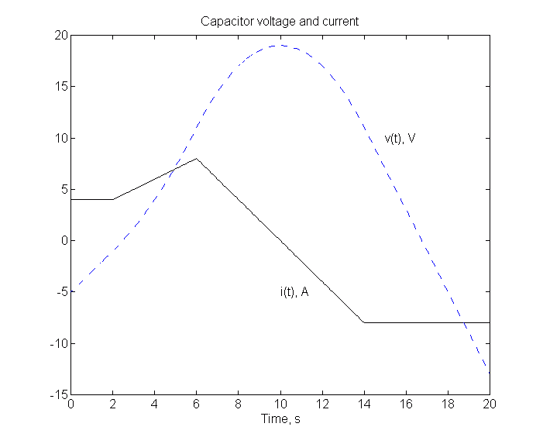
The result of running the script file on the previous page is shown below:
Figure 7.11-2 (5th and 6th editions), Figure 7.10-2 (7th edition)
A plot of the voltage and current of a capacitor.

To print a Matlab file, in the Matlab text editor select all, copy, and then paste into a word processor. In the word processor select the Matlab text and change the font to Courier New, 8 points (you may use a larger font if it does not cause the individual lines to wrap.) Print from the word processor document.

To print a Matlab Figure (graph such as the one above) In the Malab Figure Window select “Edit | Copy Figure.” Then paste the figure into a word processor document. Print from the word processor document. (You can print directly from Matlab, but then you have poor control of the print and cannot put anything else on the page.)

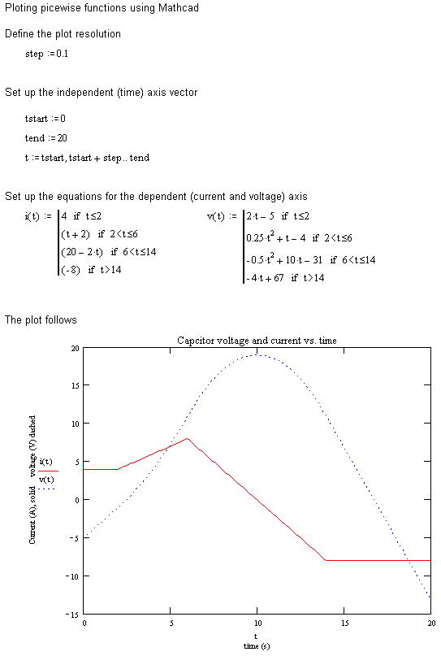

The following is copied (with minor additions and changes) from the MathCAD User Manual:

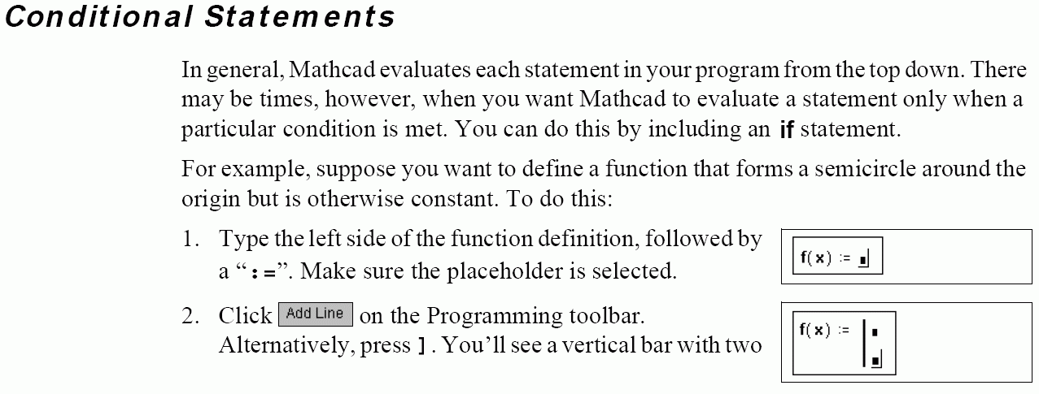
placeholders. These placeholders will hold the statements making up your
function. Click or press ] again to get additional placeholders if needed.
